Version number | Issue time | Revision brief
V1.1 | 2023/4/6 | Initial release
T-760 Instructions for use
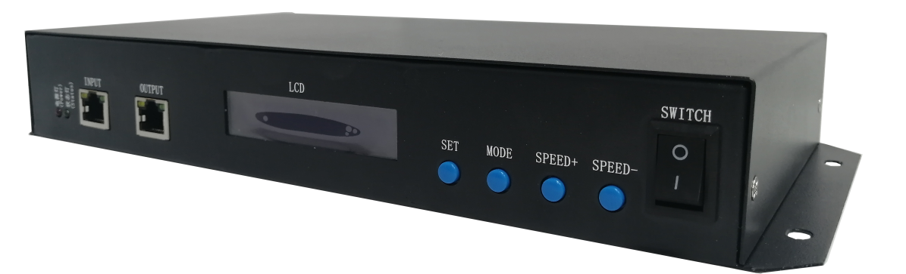
First, T-760 outstanding features
1, T-760 controller 8 port output, each port can carry SPI chip: 1024 pixels (DMX512 maximum 512 pixels).
2, T-760 controller port output two signal protocols: (1) DMX512/1990 international standard protocol and DMX512 extension protocol; ②SPI/TTL serial protocol.

Regular features:
1, the controller output port provides three protection, which can ensure that the controller output port is not damaged in the case of short circuit or reverse connection of the control lamp.
2, controller ID Automatic/manual numbering function, multiple controllers can be numbered together, or a separate controller number.
3, the controller has built-in effect, can be tested with loaded lamps (RGB/RGBW lamps are supported).
4, the controller supports single-line DMX512 write function and address test, single port or all ports with DMX512 IC write address, and the lamp address test.
5. The communication between controllers adopts the international standard TCP/IP network protocol, the optional transmission rate supports 100 Mbit/Gbit adaptive, the transmission speed is more stable and fast, the maximum transmission distance between each two controllers can reach 80 meters, more than this distance can increase the switch or use optical fiber for long-distance transmission.
6, the controller provides LCD LCD screen display, can display the control model, ID, and working status.
7, with our online video software LedPlayer to connect to the computer control, real-time monitoring of the controller connection status at the computer side. The online video software LedPlayer can be used for computer control: program timing playback, program segment selection, effect brightness adjustment, white balance online adjustment, program playback speed adjustment, display text, picture loop playback, etc., which greatly meets the various needs of customers in application and debugging; Online video software LedPlayer comes with Gamma correction, which can make the color display more delicate and bright.
8, the controller is connected to the computer to set IP address, the controller supports online, offline integrated control, online priority level is the highest, no online signal automatically switched to offline effect.
Second, support chip: (software select T-760)
Support chip | Maximum number of lights on load | remark
DMX512（UCS512,SM512,TM512,GS512） | 4096 pixels | It is recommended to carry 2400 pixels
UCS19**，ucs29**，ucs89**，ucs1603，ucs5603(UCS全系列TTL/SPI信号IC) | 8192 pixels | Recommended to carry 5120 pixels
SM16703,09,12,SM16716,16726(SM全系列TTL/SPI信号IC) | 8192 pixels | Recommended to carry 5120 pixels
TM18**系列，TM19**系列 | 8192 pixels | Recommended to carry 5120 pixels
WS28**(WS全系列TTL/SPI信号IC) | 8192 pixels | Recommended to carry 5120 pixels
GS8205,8206,8208 | 8192 pixels | Recommended to carry 5120 pixels
P9813,9823,9883 | 8192 pixels | Recommended to carry 5120 pixels
APA102 | 8192 pixels | Recommended to carry 5120 pixels
SK6812 | 8192 pixels | Recommended to carry 5120 pixels
MY9231 | 8192 pixels | Recommended to carry 5120 pixels
GW6205 | 8192 pixels | Recommended to carry 5120 pixels
INK1003 | 8192 pixels | Recommended to carry 5120 pixels
LX1003,1103,1203等 | 8192 pixels | Recommended to carry 5120 pixels
Third, product indication
T-760 Front view
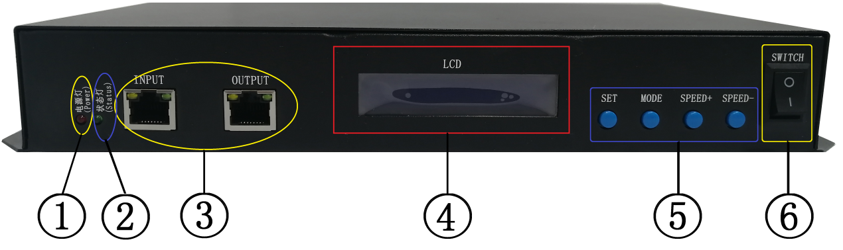
T-760 Back view
1.PowerPower indicator light | 2.StatusStatus light | 3.Cascading input network portsINPUT Expansion output network portOUTPUT
4.LCDDisplay screen | 5. Function key | 6.SwitchOFF/ON | 7. AC100-240VPower interface
8.Output portOUT1-OUT8
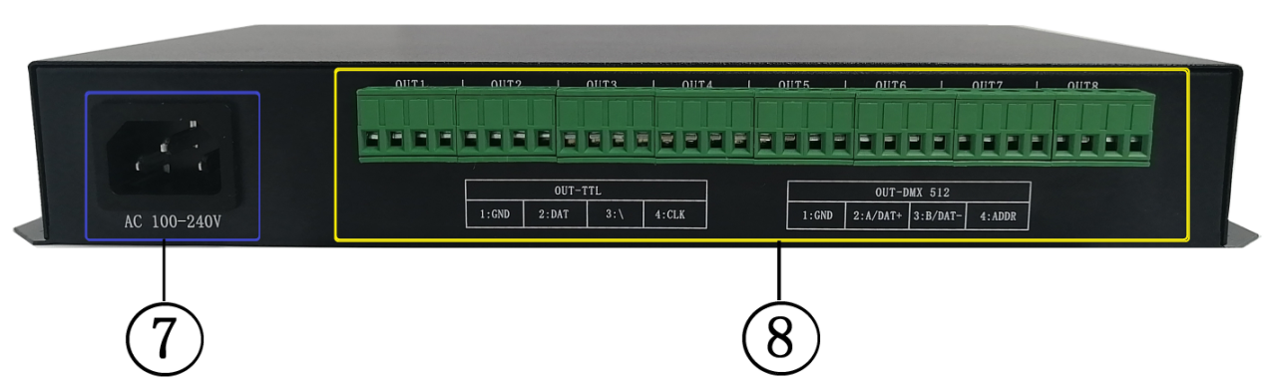

4. Indicator light and button definition
1. Pilot lamp
Power | Power indicator (steady on after power on)
Status | Status indicator (always on during normal operation/stroboscopic during writing)
2. Cascade signal input and output
Cascade signal |  | remark
INPUT | Expansion signal input network port | The output of the upper level controller is connected IN and OUT of the next level controller | INPUTThe indicator stroboscopic when there is signal input
OUTPUT | Expansion signal output network port |  | OUTPUTStroboscopic when the indicator has signal output
3. Signal outlet
OUT1—OUT8 | Port definition  Signal type | 1 | 2
 | Signal output (TTL/SPI signal) | GND | DATdata
 | Signal output (DMX512 signal) | GND | A/DAT+ Positive signal
4. Key function
 | SET Set key | MODE Menu key | SPEED+ | SPEED-
Play/Regular mode | / | / | / | /
Numbering pattern | Numbered start key | / | Digital addition | Digit subtraction
Parameter setting mode | Parameter setting/entry | Item selection | Parameter adjustment + | Parameter adjustment -
remark | Normal boot into the normal mode, the button does not work | Press "SET" to boot and enter the parameter setting mode/function setting |  | Press - to start the system and enter the numbering mode
5. Display definition:
reveal |  | definition
 | Play mode | ID: 001 (No. 1)  PLAY >>> Online/master play  STOP >>> Online/Master - Pause
 | Conventional mode | ID: 001(No. 1)  GE/FE: Gigabit / 100 Gigabit transmission rate  A/C: Automatic/manual number  Model: T-760
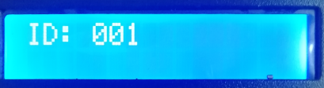 | Numbering pattern | ID：*** Start ID
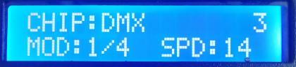 | Built-in effect  Play mode | CHIP: Chip 3: light channel  MOD: Built-in effect SPD: playback speed
Five, wiring diagram
1. Computer connection diagram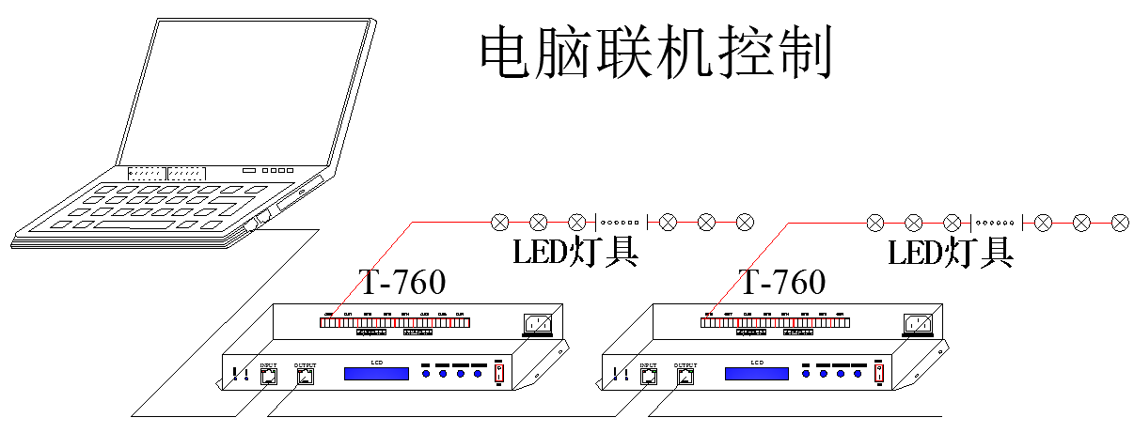
2. The offline master uses the connection diagram offline
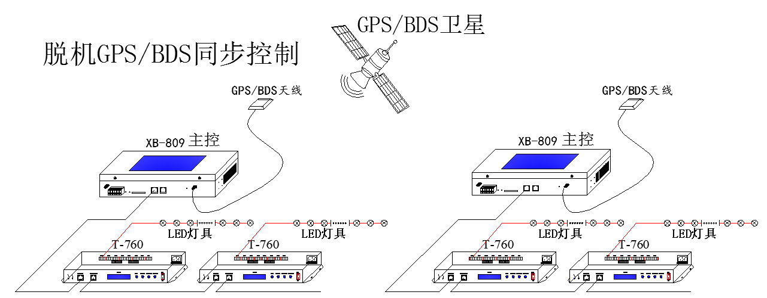
3. Use the connection diagram online and offline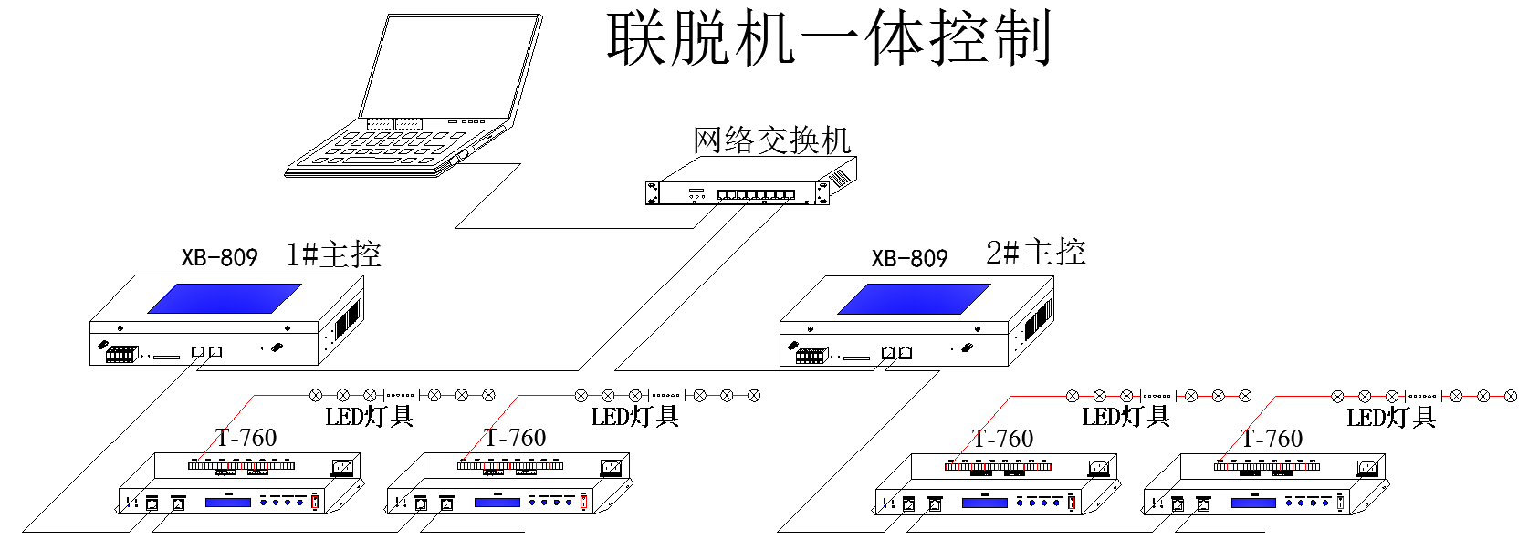

4. Controller signal output port wiring diagram
①. Conventional lamp wiring diagram ②.DMX512 differential signal line wiring diagram
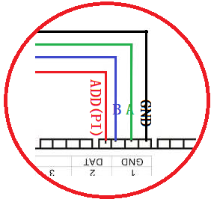
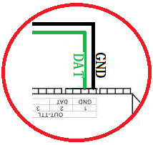

③. DMX512 single line signal line wiring diagram ④. DMX512 differential signal line wiring diagram (AB line addressing)

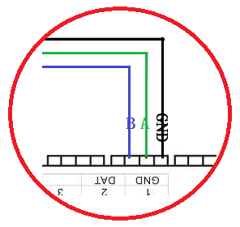
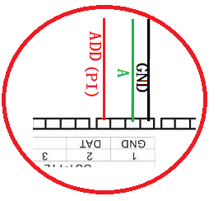

5. Controller -- online mode -- computer IP address setting
1. Open the computer - Network and Sharing Center;
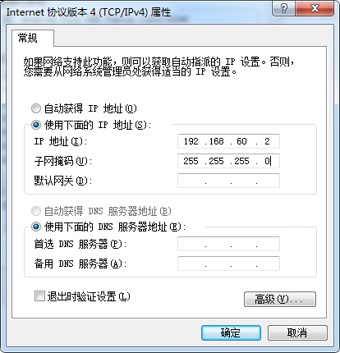
2. Click Change adapter Settings;
3. Right-click Local Area Connection - Properties.
4. Click Internet Protocol Version 4 (TCP/IPV4).
5. Change the IP address
IP address: 192.168.60.2
Subnet mask: 255.255.255.0
6. Click OK to complete the IP address setting.

Six, T-760 number function operation
The T-760 is numbered in three ways: computer end number, master end number, and sub-control end number.
1. Controller (computer software) number
1.1. The computer and the controller are connected by network cable (using the international standard TCP/IP network protocol, the network cable is 568B straight-through).
1.2. Open the software LedPlayer-k and click "Project Configuration" as shown in Figure 1
1.3. Click "Online Coding", as shown in Figure 2
1.4. Set the start number of the controller and click the online number button to start the number, as shown in Figure 3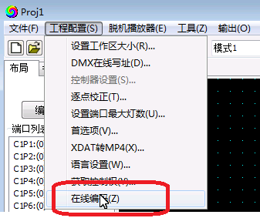 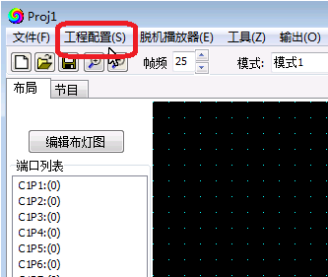 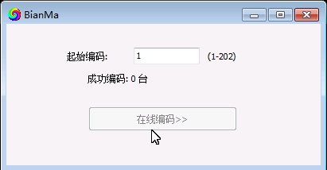
图1 图 2 图3
1.5. Complete online coding and check each T-760 controller number.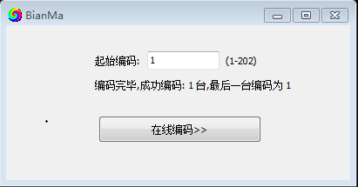

2. Controller (operation at the main control end) numbering function The main control and sub-control (T-760) are connected through network cables (using the international standard TCP/IP network protocol, the network cable is 568B straight-through).
2.1. The main control holds down the "SPEED-/ Speed -" key to power on, and the "MODE" key adjusts the arrow to "Set Slave ID" as shown in the following figure:
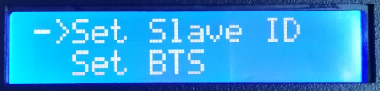
2.2. Press the "SET" key again, and the numbering page is displayed in the main control. The "SPEED+ /SPEED+" key and "Speed -/SPEED-" key adjust and set the numbering number of the start sub-controller, as shown in the following figure: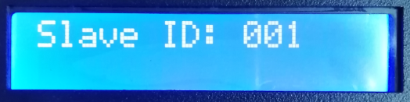
2.3. After setting the number, press the "SET/ Save" key to start the number.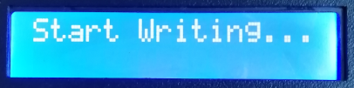
2.4. Controller number The first step automatically counts the number of sub-controllers, and the display "Write OK:003" (take 3 sub-controller numbers as an example)
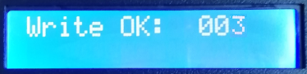
2.5. After the numbering is complete, the main control is displayed as follows: 3 controllers are programmed in "Write Num: 003"
Last ID: 003 The number of the last controller is 3
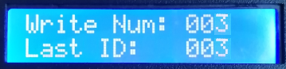
The sub-control T-760 is shown as follows:
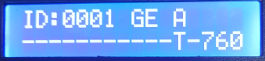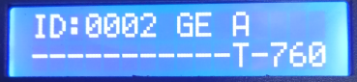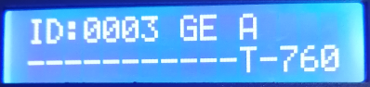
ID of the first device: 0001 ID of the second device: 0002 ID of the third device: 0003
2.6. Check the controller number. If you need to renumber the controller, hold down the SPEED- /SPEED- key to start the numbering again. If you do not need to renumber, press any key - Master restart, return to play mode.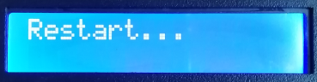
Note 1: When the controller is numbered, the network ports must be connected IN strict accordance with the controller silk screen prompt (IN/OUT) sequence; The maximum sub-control number is 203.
3. Number of the controller (T-760 controller)
Network cable connection between T-760 and T-760 (using the international standard TCP/IP network protocol, the network cable pressing mode is 568B straight-through)

3.1. On the first controller, hold down the SPEED- button and do not let go. The controller starts up and enters the manual coding mode. ID:0001 is displayed as shown in the figure.
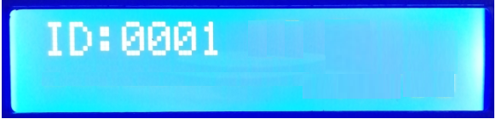
keyscreen | SET设置键 | MEUN菜单键 | SPEED+/速度+ | SPEED- /速度-
Key function | Numbered start key | / | Digital+ +addition | Digit -subtraction
备注 | Numbering MODE, the Mode menu key is inactive用 |  | Press - to start the system and enter the numbering mode
3.2. After adjusting the start number, press the "SET" key to start the start number, and the "Writing..." will be displayed.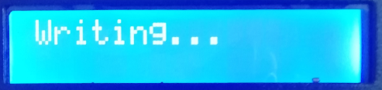
3.3. During the numbering process of controllers, the number of connected controllers (number of connected controllers) is detected. As shown in Figure 003, a total of 3 controllers are detected.
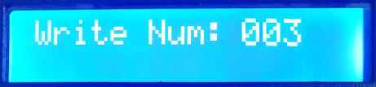
3.4. After the number is complete, the first controller is displayed, as shown in Write Num: 003. Three controllers are found
Last ID: 003 The number of the last computer is 3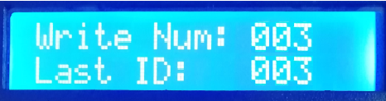
Other controller display: as shown in the figure:
ID:0002 A; ID:0002 indicates that the controller number is 2. A: indicates that the controller number is automatically generated
Second: A-0002 Third: A-0003
3.5. Check whether each controller is correctly numbered and needs to be renumbered. Hold down SPEED- on the first T-760 controller to return to manual numbering. End No. Press any key to exit. Restart the first T-760 controller. , return to normal play mode.
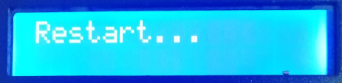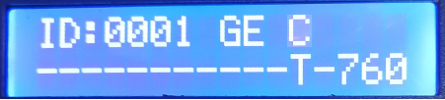

Note: When the controller is numbered, the network ports must be connected in strict accordance with the INPUT/OUTPUT sequence prompted by the controller screen.
7. T-760 parameter setting and function operation
Press the SET key. The controller is powered on at the same time. The screen for parameter setting and other functions is displayed。

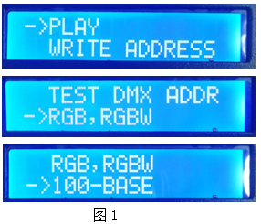
1.play built-in effect playback mode
② WRITE ADDRESS Write address mode
③. TEST DMX ADDR Test mode of the luminaire address
4. RGB,RGBW lighting channel selection mode
⑤. 100-BASE transmission rate selection mode
1. Built-in effect mode (supports RGB/RGBW lamps with two channels)
1.1. Press the "SET" key to start the controller at the same time, and enter the interface for parameter setting and other functions, as shown in the figure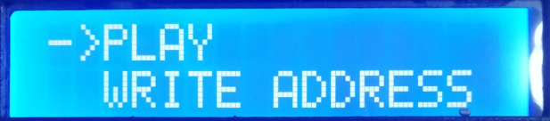

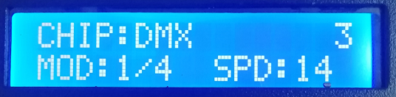
1.2. Press MODE to move the arrow to select PLAY, and then press SET to enter the Play mode screen. As shown in the figure:
①. CHIP chip model (see IC model list)
②. 3 Channel selection (3/4)
③. MOD built-in effects (see list of built-in effects)
④. SPD playback speed (see the list of frame rates corresponding to speed levels)
Note: When the built-in effect is played, the lamp channel can be set by "Lamp channel selection Mode".
1.3. Key menu
按键丝印 | SET设置键 | MODE菜单键 | SPEED+/速度+ | SPEED- /速度-
功能 | Chip selection | mode selection | 速度+ | 速度-
备注 | Press "SET" to boot and enter the built-in effect mode

1.4. Press the SET key to switch the IC model
IC型号列表
1 | DMX (标准250Kbps) | 5 | TM1803
2 | UCS1903 | 6 | GS8205
3 | SM16703 | 7 | DMX 500K
4 | WS2811 | 8 | DMX 750K

1.5. Press the MODE menu key to switch the built-in effect
内置效果列表
1 | 七彩跳变 | 3 | 七彩推移
2 | 七彩渐变 | 4 | 白光渐变

1.6. Press "SPEED+/ SPEED+" and "SPEED- / Speed -" to switch the speed:
速度等级对应帧频列表
速度 | 帧频/秒 | 速度 | 帧频/秒 | 速度 | 帧频/秒 | 速度 | 帧频/秒
1 | 4帧 | 5 | 8帧 | 9 | 14帧 | 13 | 23帧
2 | 5帧 | 6 | 9帧 | 10 | 16帧 | 14 | 25帧
3 | 6帧 | 7 | 10帧 | 11 | 18帧 | 15 | 27帧
4 | 7帧 | 8 | 12帧 | 12 | 20帧 | 16 | 30帧

1.7. After the built-in effect is played, shut down and restart to return to the normal mode.
2. DMX512 IC write mode and test
2.1. Press the "SET" key while the controller is powered on, and the interface for parameter setting and other functions is displayed, as shown in Figure 1.
2.2. Press the MODE key to move the arrow to select WRITE ADDRESS, as shown in the figure
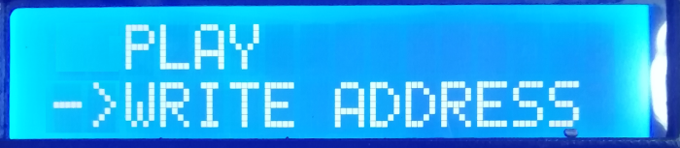

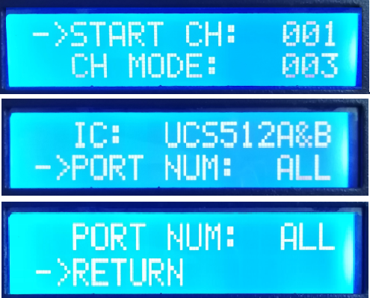
2.3. Press "SET" to select "WRITE ADDRESS" to enter the write address mode interface, as shown in the following figure:
① START CH: indicates the start channel
(The starting address is set in the range of 0-512, usually 001)
②. CH MODE: indicates an interval channel
(Interval channel Settings 0-255 range)
③. IC: chip model
(See list of DMX512 ics)
PORT NUM: indicates the write address port
(See list of ports)
⑤. RETURN Returns to the main screen2.4. Press MODE to move the arrow item, and press SPEED+ and SPEED- to set the start channel, interval channel, IC option, and write port respectively.

2.端口代码表
1 | 端口OUT1 | 2 | 端口OUT2 | 3 | 端口OUT3 | 4 | 端口OUT4
5 | 端口OUT5 | 6 | 端口OUT6 | 7 | 端口OUT7 | 8 | 端口OUT8
ALL | 全部端口OUT1-8
Note: The controller can write to all ports, but also supports single-port write

2.5. Select to complete each project, press "SET" to start writing address; "Writing Addr..." is displayed. The port indicator is blinking.
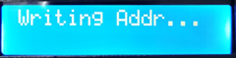
2.6. After the address is written, the controller automatically jumps to the address test function, and the screen displays at this time
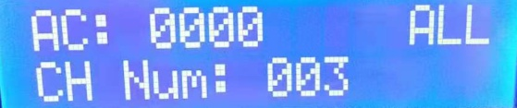
①. AC: **** Automatic test
②. MC: **** Manual test
③. ALL All ports OUT1-8
④. CH MODE: channel (The interval channel cannot be adjusted)
Note: The write PORT is set by PORT NUM port number when writing

2.7. Press the "MODE" key to enter the "AC" automatic test mode, and the lamp starts to turn on the lamp successively; The controller is shown as follows: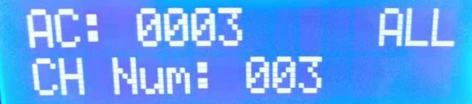
2.8. Press the "MODE" key again to enter the "MC" manual test mode, "SPEED+" and "SPEED-" can adjust the pixels (long press "Speed +" or "speed -" can rapidly increase or decrease), and the lamps will be lit one by one; The controller is shown in the following figure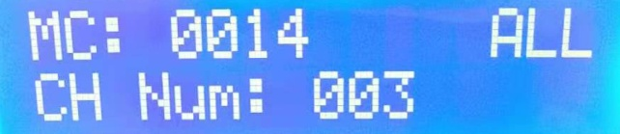
2.9. After the test is completed, press "SET" to exit the channel test and return to the write interface
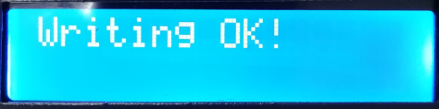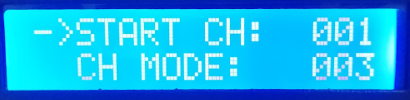
2.10. After writing the address, shut down and restart, and return to the normal mode.

4. Lamp channel selection mode (built-in effect playback supports RGB/RGBW IC channel selection)
4.1. Press the SET key. When the controller is powered on, the screen for setting parameters and other functions is displayed.
4.2. Press MODE to move the arrow to select RGB,RGBW. 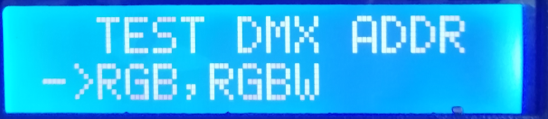
4.3. Press "SET" to enter the channel mode selection interface of lamps and lanterns, as shown in the figure:
① RGB three-channel lamps
② RGBW four-channel lamps
4.4. Press SPEED+ and SPEED- to move the arrow up and down and select the RGB/RGBW channel option.
4.5. Press the "MODE" key to confirm the selection, as shown in the following figure:
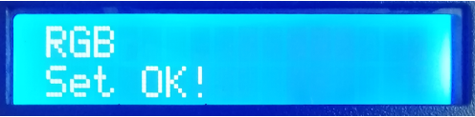 perhaps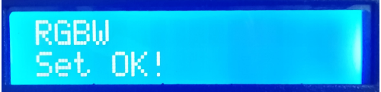
4.6 After selecting the luminaire channel, press "SET" to exit and return to the main screen.

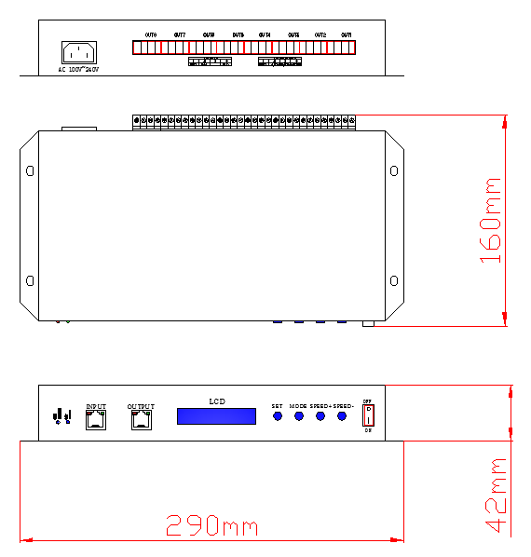
8. Physical parameters
Operating temperature: -20℃ -75 ℃
Power supply: AC 100-240V input
Power consumption: 5W
Weight (gross weight) : 1.5Kg
Output type: 4pin terminal *8
Dimensions: L290mm * W160mm * H42mm
With outer packing: (power cord *1; Screwdriver *1; Certificate *1; Carton

*1)Ix. Precautions:
1. Between controller and controller, controller and main control, controller and computer, each two nodes can be cascaded with a maximum of 100 meters of network cables of more than five specifications, and over this distance, switches can be added or optical fibers can be used for long-distance transmission.

2. The cable is laid in 568B straight-through mode